LIGHTWEIGHT TRANSFER-LEARNER FRAMEWORK FOR MULTISTAGE ALZHEIMER’S DETECTION IN MRI SCANS
Hemant Kumar Sachdev¹, Aswath S², Bharathkumar Y³, Kanimozhi S⁴
¹B.E. Computer Science and Engineering (Artificial Intelligence and Machine Learning), KPR Institute of Engineering and Technology, 641407, Coimbatore, Tamil Nadu, India.
²B.Tech. Computer Science and Business Systems, KPR Institute of Engineering and Technology, 641407, Coimbatore, Tamil Nadu, India.
³B.E. Biomedical Engineering, KPR Institute of Engineering and Technology, 641407, Coimbatore, Tamil Nadu, India.
⁴Professor, B.E. Biomedical Engineering, KPR Institute of Engineering and Technology, 641407, Coimbatore, Tamil Nadu, India.
Emails: 22am021@kpriet.ac.in¹, 22cb008@kpriet.ac.in², 22bm010@kpriet.ac.in³, kanimozhi.s@kpriet.ac.in⁴
Abstract
Millions of people around the world experience memory loss and cognitive decline due to Alzheimer's disease (AD), which is a progressive neural disorder. Detecting it early with MRI imaging can significantly improve diagnosis and treatment planning. However, interpreting MRI scans by hand is subjective and takes a lot of time. This paper introduces an automated, lightweight deep learning method for classifying the stages of Alzheimer's using transfer learning with MobileNetV3. The system prepares MRI images by resizing, normalizing, and enhancing them to improve generalization. Images are slightly rotated, flipped and adjusted in brightness to help the network learn from multiple variations allowing model to become more reliable and less overfitted. MobileNetV3 has frozen feature extraction layers along with custom dense layers. It divides MRI scans into four categories: Non-Demented, Very Mild Dementia, Mild Dementia, and Moderate Demented. The evaluation covers how well classification performs considering model’s accuracy, precision, recall and F1-score. A web interface built on Streamlit allows real-time image uploads and instant predictions, making it useful for clinical and research applications. This study connects AI-based image analysis to healthcare by providing an efficient and clear way to detect Alzheimer’s. Additionally, it demonstrates high efficiency in computation making it suitable to deploy on low-resource devices and environments.
Keywords: Alzheimer’s disease; Anomaly detection; MRI image classification; Overfitting; Transfer learning.

- INTRODUCTION
MRI’s, Magnetic Resonance Imaging, it serves as a critical and crucial modal in diagnosing neurological disorders, especially Alzheimer’s disease. Its ability of producing high-resolution brain anatomy images enables the detection of early indicators of structural changes and decline in cognitivism. Nevertheless, the diagnostic workflow often depends on manual evaluation by the radiologists, which can be time intensive and subject to human variability influenced by individual expertise. DL has become an attractive alternative for automating tasks in medical imaging, overcoming many limits of older, hand-crafted approaches. 1 Convolutional neural networks (CNNs) excel at picking up the subtle, high-dimensional patterns found in scans, and transfer learning makes it realistic to apply these models even when labeled medical datasets are small. By starting from networks pretrained on large image corpora and fine-tuning them on medical images, we can reduce training time while retaining strong predictive performance. MobileNetV3, a lightweight and efficient CNN architecture, is especially suitable for medical applications where computational resources may be limited. By leveraging MobileNetV3 with transfer learning, it becomes possible to build scalable, fast, and accurate systems for detecting anomalies in MRI scans. Such an approach enables real-time classification, supports deployment on edge devices, and enhances the reliability and accessibility of neurological diagnostics across clinical and research settings.
  - Related Works
Detection of anomalies in medical imaging, particularly brain MRI scans, is emerging as a important area of research due to its potential for early identification of neurological disorders such as Alzheimer’s disease. Traditional MRI diagnosis depends heavily on manual interpretation by radiologists, which introduces subjectivity and delays in diagnosis. To reduce human error and improve diagnostic efficiency, researchers have increasingly adopted automated systems based on AI&ML.
Recent advancements in DL, especially in applications of Convolutional Neural Networks (CNNs), enabled automated systems for detecting subtle and complex patterns in MRI data. These models learn features directly from the given input images, minimizing the requirement for feature engineering manually. They can process vast data volumes and provide high accuracy makes them ideal for applications in medical diagnostics.
A variety of methods have been explored in literature: Autoencoder-Based (Baur et al., 2018; Wiestler et al., 2021; Behrendt et al., 2022), GAN Based (MADGAN 2020), Clustering (Govindaraj 2020), Transformer-Based (Ghorbel 2022), Traditional Segmentation-Based methods (Bharath 2022), Statistical Approaches (Kim 2021), Self Supervised Learning (Cai 2023), and Diffusion Based (Wyatt 2022, Behrendt 2024). In addition, review papers (Fernando 2021, Lagogiannis 2023) provide extensive surveys and comparisons of these techniques.
  - Deep learning approaches for Brain MRI Classification
Many studies have applied CNNs and their variants for the classification of brain MRI scans. These models are trained to distinguish between normal and abnormal scans or to segment specific brain anomalies. While binary classification is common, recent research has started exploring multi class classification systems to distinguish between various cases of diseases like Alzheimer’s.
Transfer learning is a prominent approach in this field. Instead of training deep networks from scratch, models like MobileNet, ResNet, and VGG are pre trained on vast datasets and then they are tuned finely on medical images. This method reduces computational requirements and allows for effective training even with limited medical data.
Despite these advancements, there remains a need for models that are not only accurate but also lightweight and deployable in real-time. Most existing models are resource-intensive and lack user-friendly deployment mechanisms. Thus, the integration of efficient architectures like MobileNetV3 for multi-class classification in Alzheimer’s detection remains underexplored.
  - Data Augmentation and Preprocessing Techniques
Data preprocessing is a basic step when building reliable models for MRI analysis. Standard practices involve:
- Grayscale conversion to make channel information easier.
- Resizing to uniform dimensions (e.g. 224x224 pixels) for model compatibility.
- Normalization to scale pixel intensity values.
- Data augmentation (use flips, rotations, zoom) to make generalization better.
These preprocessing techniques help to reduce the issues of overfitting, improve the intelligence of the model and making sure that model learns meaningful patterns from a set of diverse data inputs.
  - Role of Transfer Learning
Transfer learning is playing an important role in overcoming challenge of small labeled medical datasets. By utilizing pre-trained models like MobileNetV3, developers can build efficient and accurate models by only retraining the final layers on MRI datasets.
This approach speeds up training and also significantly improves performance, especially when combined with regularization techniques such as dropout and early stopping. For our project, MobileNetV3 was selected due to its lightweight architecture, making it suitable towards the real-time applications and web-based deployment.
  - Tools and Frameworks Used In Previous Works
Many use the following given tools and frameworks:
- Python: For data handling and model development
- TensorFlow / Keras: For building and training the DL models
- OpenCV: For preprocessing image and transformations
- NumPy/Pandas: For exploration of data and manipulating it.
- Streamlit or Flask: For creating the web-based UI’s for real-time inference from the models.
These ensure a flexible, open-source environment which supports both deployment and experimentation of medical imaging solutions.
  - Research Gaps Identified
Even though the incredible advancement in the DL field of medical imaging, various limitations still exist:
- There is not much attention given to the lightweight model that can do the real-time inference.
- Multi-class classification systems for stages of Alzheimer's are not often implemented; most will be binary outputs.
- Few studies focus on deployment and accessibility - i.e. intuitive user interfaces for clinical or research use are absent.
Model interpretability and generalisability on diverse datasets are still areas that warrant further exploration.
  - Comparative Summary of CNN Architectures Used in Medical Imaging
DL models have been extensively used in image analysis in medical domains, particularly for MRI-based disease detection. Different CNN architectures vary in depth, parameters, accuracy, and computational requirements. The table below summarizes commonly used models:

Table 1. Comparison of Popular CNN Architectures
Model | Params | Strengths | Limitations
VGG16 /  VGG19 | 138M+ | Simple architecture, strong feature extraction | Heavy model, slow inference, high memory consumption
ResNet50/ ResNet101 | 25M–45M | Excellent accuracy, solves vanishing gradient problem | Requires high computational power
DenseNet121 | 8M | Efficient feature reuse, fewer parameters | Difficult to train for deployment on low-end devices
EfficientNet | 5M–66M | High accuracy with optimized scaling | More complex architecture
MobileNetV2/V3 | 2M–5M | Very lightweight, fast, ideal for mobile & edge devices | May require fine-tuning for best accuracy

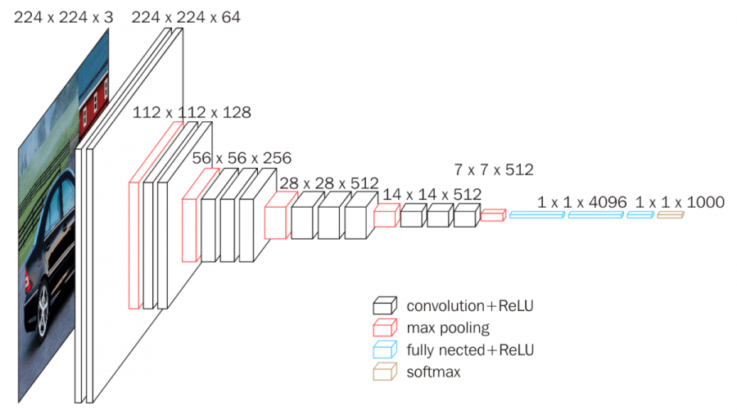
FIGURE 1: VGG Networks and Architecture.

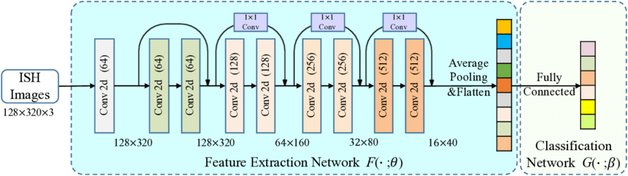
FIGURE 2: ResNet Architecture.

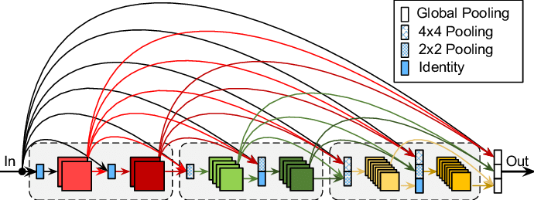
FIGURE 3: DenseNet-121 Architecture.

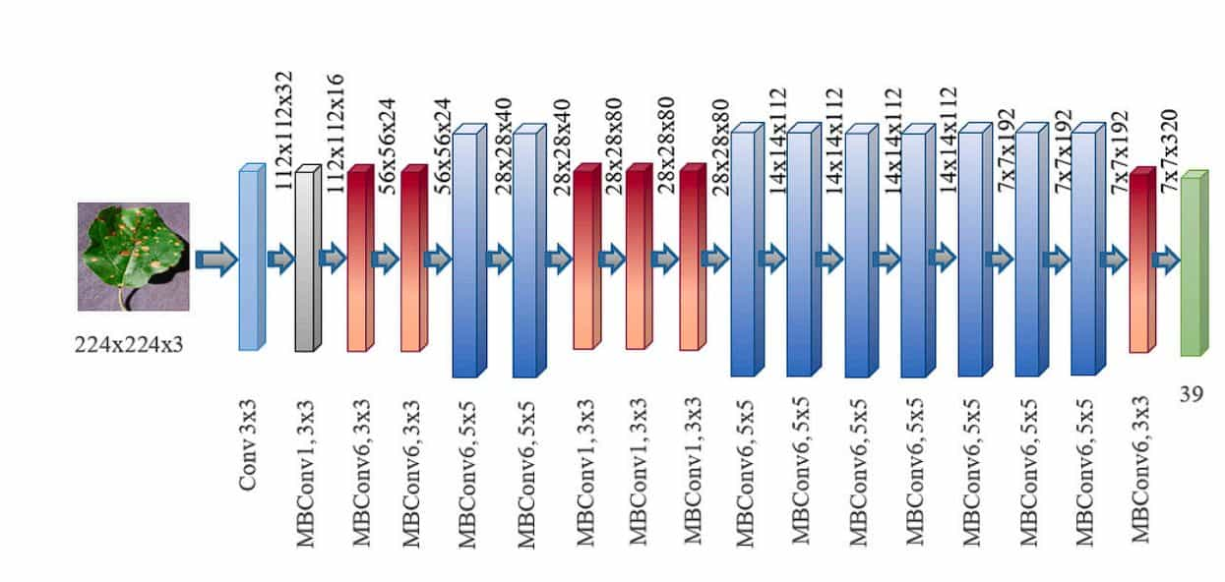
FIGURE 4: EfficientNet Architecture.

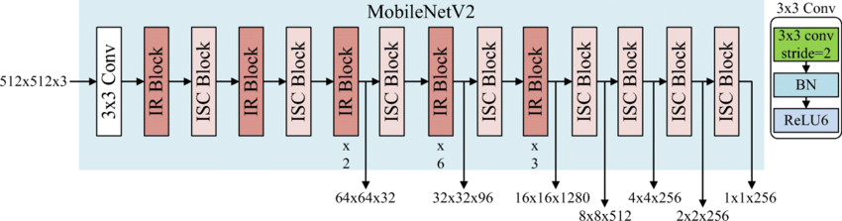
FIGURE 5: MobileNet V2 Architecture.

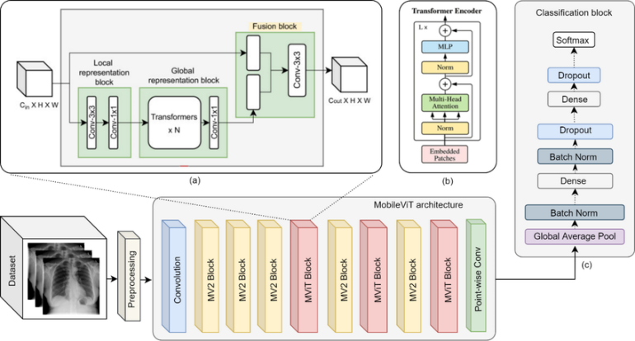
FIGURE 6: Mobilenet V3 Architecture.

- METHOD
  - System Pipeline
The overall system pipeline of the proposed framework is being shown in Figure 7. The pipeline consists of four major stages: preprocessing, feature extraction, classification, and output generation. In the preprocessing stage, raw MRI brain images are being resized to a fixed input resolution compatible with the MobileNetV3 architecture. Intensity normalization is applied to reduce variations caused by different scanning conditions and imaging devices. This step ensures consistent input distribution and improves the convergence by the model during its training. In the feature extraction stage, the preprocessed images are passed through a pre-trained MobileNetV3 backbone. The network automatically learns hierarchical features which are ranging from the low-level texture patterns to the high-level semantic representations relevant to Alzheimer’s disease progression.
The extracted deep features are then forwarded to the classification stage, which consists of fully connected layers designed to map learned representations to clinical Alzheimer’s stages. Finally, the output stage produces class probabilities corresponding to different Alzheimer’s severity levels, enabling accurate diagnosis.

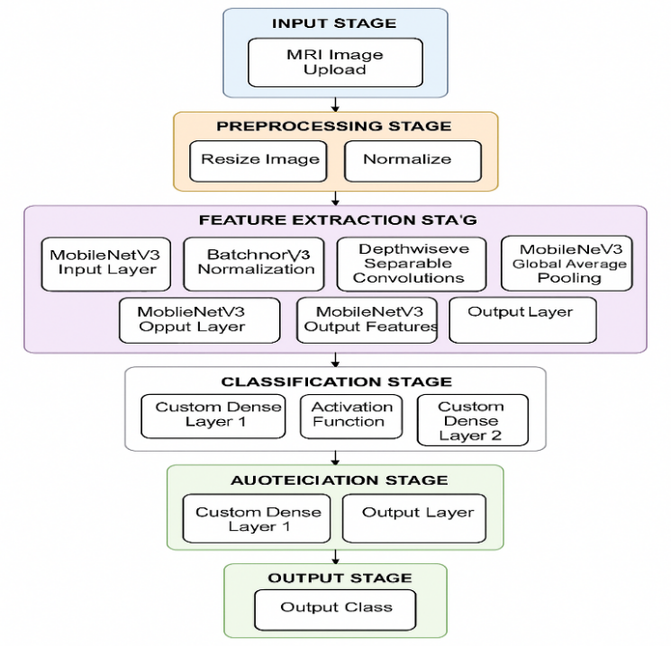
FIGURE 7: Full pipeline of the proposed lightweight Alzheimer’s detection framework, showing preprocessing, feature extraction, classification, and output stages.

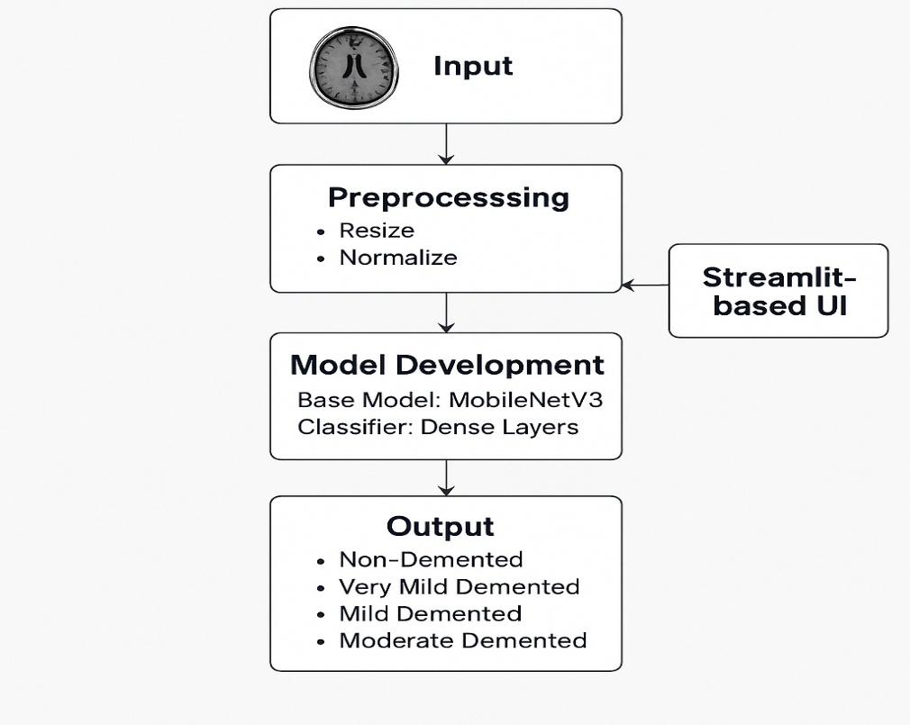
FIGURE 8: Overall Flow.
  - Dataset Description and Distribution
The OASIS MRI dataset is used, containing T1-weighted brain MRI scans categorized into four Alzheimer’s stages.

Table 2: Dataset Class Distribution
Class | Number of Images
Non-Demented | 15000
Very Mild Demented | 15000
Mild Demented | 15000
Moderate Demented | 15000
  - Figures Data Preprocessing and Augmentation
    - Image Normalization
Each MRI image $I$is normalized using:
$$I_{norm}=\frac{I-min⁡(I)}{max⁡(I)-min⁡(I)}$$
It ensures the consistency of pixel intensity across datasets.
    - Data Augmentation
Augmentation techniques which are applied include:
• Rotation (±15°)
• Horizontal flipping
• Zoom scaling
• Brightness variation
These transformations increase dataset diversity and reduce overfitting.
  - MobileNetV3 Architecture
MobileNetV3 is selected as the backbone network due to its optimal trade-offs between the accuracy and the computational efficiency. It combines the strengths of MobileNetV1’s depthwise separable convolutions and MobileNetV2’s inverted residual blocks, while incorporating Squeeze-and-Excitation (SE) modules and hard-swish activation functions for enhanced performance.
The depthwise separable convolution usaually decomposes standard convolution towards two operations: depthwise convolution and pointwise convolution. The depthwise convolution is defined as:
$$Conv_{DW}(x)=\sum_{i=1}^{k}{w_{i}}⋅x_{i}$$
where k represents the size of the kernel, w is the depthwise filter weights and x_{i} is the input feature map values.
This operation greatly reduces the number of parameters and the floating point operations as compared to the normal convolutions. The depthwise convolution is followed by pointwise (1x1) convolution that is used to combine channel wise information and further refine the feature representation. This architectural design makes MobileNetV3 a good candidate for medical imaging applications in edge devices.
  - Classification Layers
The head of classification is composed of global average pooling followed by fully connected (dense) layers. Global average pooling helps in reducing the spatial dimensions of the feature maps, minimizing overfitting and reducing the number of trainable parameters.
The final dense layer uses the Softmax activation function for generating the normalized probability scores for each Alzheimer’s stage:
$$P(y=j∣x)=\frac{e^{z_{j}}}{\sum_{k=1}^{C}{e^{z_{k}}}}$$where $z_{j}$denotes the logit value for class $j$, and $C=4$represents the number of Alzheimer’s cases (e.g., Non-Demented, Very Mild Demented, Mild Demented, and Moderate Demented). The predicted class corresponds to the maximum probability score.
  - Training Strategy
    - Loss Function
In order to optimize the multi-class task, Categorical Cross-Entropy Loss is used. This loss function effectively calculates the discrepancy among the true class distribution and the predicted probability distribution:
$$L=-\sum_{i=1}^{N}{\sum_{c=1}^{C}{y_{ic}}}log⁡({\hat{y}}_{ic})$$Where: is the number of training samples; is the ground truth label; is the number of training samples in class c; is the predicted probability of the class c. This loss is used to encourage the model to give larger probabilities to the correct Alzheimer's stage.
    - Optimization
The Adam optimizer is utilised for training because to its adaptive learning rate mechanism and fast properties of convergence. Adam, hence combines the advantages from both momentum-based gradient descent and RMSProp by maintaining the first-order and the second-order moment estimates for the gradients. The parameter update rule is given by:
$$θ_{t+1}=θ_{t}-α\frac{m_{t}}{\sqrt{v_{t}}+ϵ}$$where $α$is the learning rate, $m_{t}$and $v_{t}$are the first and second moment estimates, and $ϵ$is a small constant to prevent division by zero. This strategy of optimization ensures stable and efficient training.
    - Regularization
To mitigate overfitting, Dropout regularization with a dropout rate of 𝑝 = 0.3is applied to the fully connected layers. Dropout randomly deactivates neurons during training, forcing the network to learn robust and generalized feature representations. Additionally, early stopping is employed by monitoring validation loss during training. Training is halted when performance no longer improves, preventing unnecessary epochs and reducing the risk of overfitting.

  - Evaluation Metrics
The performance of the proposed framework is evaluated using standard classification metrics, as summarized in Table 2. These metrics provide a comprehensive assessment of the model’s diagnostic capability.
Table 3: Performance Metrics Definitions
Metric | Formula
Accuracy | $$\frac{TP+TN}{TP+TN+FP+FN}$$
Precision | $$\frac{TP}{TP+FP}$$
Recall | $$\frac{TP}{TP+FN}$$
F1-Score | $$2⋅\frac{Precision⋅Recall}{Precision+Recall}$$

Accuracy measures overall correctness, precision evaluates the reliability of positive predictions, recall assesses the model’s ability to identify Alzheimer’s cases, and the F1-score provides a balanced measure between precision and recall, making it particularly suitable for medical diagnosis tasks with class imbalance.

- RESULTS AND DISCUSSION
  - Results
detection system has been successfully implemented and evaluated, demonstrating its effectiveness in classifying brain MRI scans across multiple stages of dementia. The system utilizes MobileNetV3, a lightweight convoluting architecture of neural network which is optimized with transfer learning, enabling high classification accuracy while maintaining computational efficiency. The model is trained and tested on preprocessed MRI data categorized into the four distinct classes: Mild, Very Mild, Mild, Moderate, and Non-Demented. The experimental evaluation involved multiple performance analyses, including per-class F1-score, recall, precision, normalized confusion matrix and ROC-AUC curves. The results validated the system’s robustness, generalization ability, and reliability in detecting subtle anomalies indicative of Alzheimer’s disease progression. The per-class performance metrics (Figure 10) revealed strong predictive behavior across all classes, with the model achieving high precision (0.976) for the Non-Demented class, reflecting its ability to correctly identify healthy cases. The Moderate Demented class achieved the highest recall (1.000), indicating the model’s strong sensitivity towards advanced stages of dementia. The F1-scores for most classes exceeded 0.85, demonstrating a trade-off which is balanced between recall and precision. Although the Very Mild Demented class showed slightly lower precision (0.530), its recall remained relatively high (0.853), suggesting that the model effectively recognizes early dementia cases but occasionally confuses them with adjacent stages — an expected challenge due to subtle MRI feature overlaps. The ROC, Receiver Operating Characteristic curves (Figure 11) further highlighted the model’s strong discriminative capability. The Area Under Curve (AUC) values were notably high across all categories — Moderate Demented (1.000), Mild Demented (0.986), Very Mild Demented (0.930) and Non Demented (0.936) and. These results confirm that the classifier maintains excellent separability between classes, particularly for moderate and mild dementia, where structural brain changes are more pronounced. The ROC curves positioned well above the random baseline, indicating minimal false-positive rates and robust classification boundaries. The normalized confusion matrix (Figure 9) provided deeper insights into the classification outcomes. The system correctly classified 93.07% of Mild Demented, 85.33% of Very Mild Demented, 80.29% of Non-Demented, and 100% of Moderate Demented cases. Most misclassifications occurred between adjacent categories (Non-Demented ↔ Very Mild Demented and Very Mild Demented ↔ Mild Demented), which aligns with the progressive nature of Alzheimer’s disease where early symptoms are difficult to differentiate visually. Importantly, no Moderate Demented images were misclassified, underscoring the model’s reliability in detecting severe dementia cases.
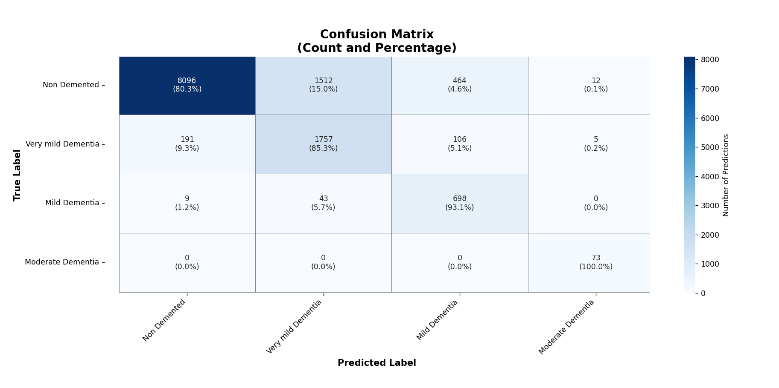
FIGURE 9: Confusion Matrix for Classes.
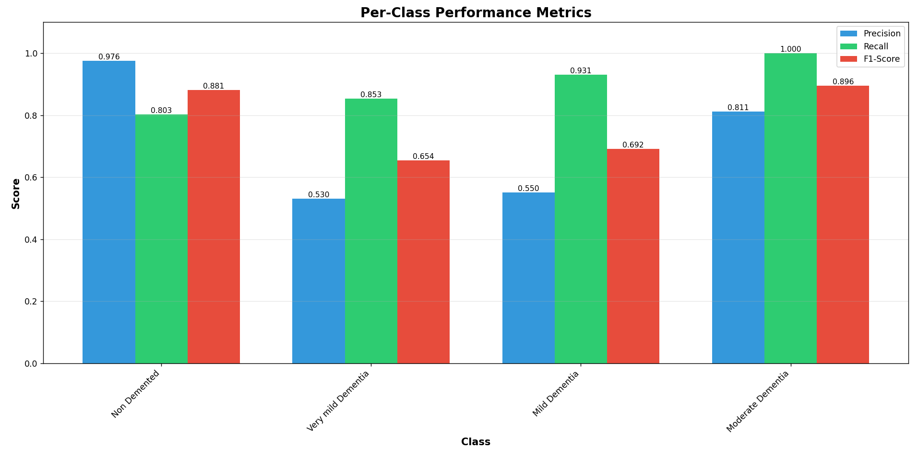
FIGURE 10: Precision, Recall and F1-Score among classes.

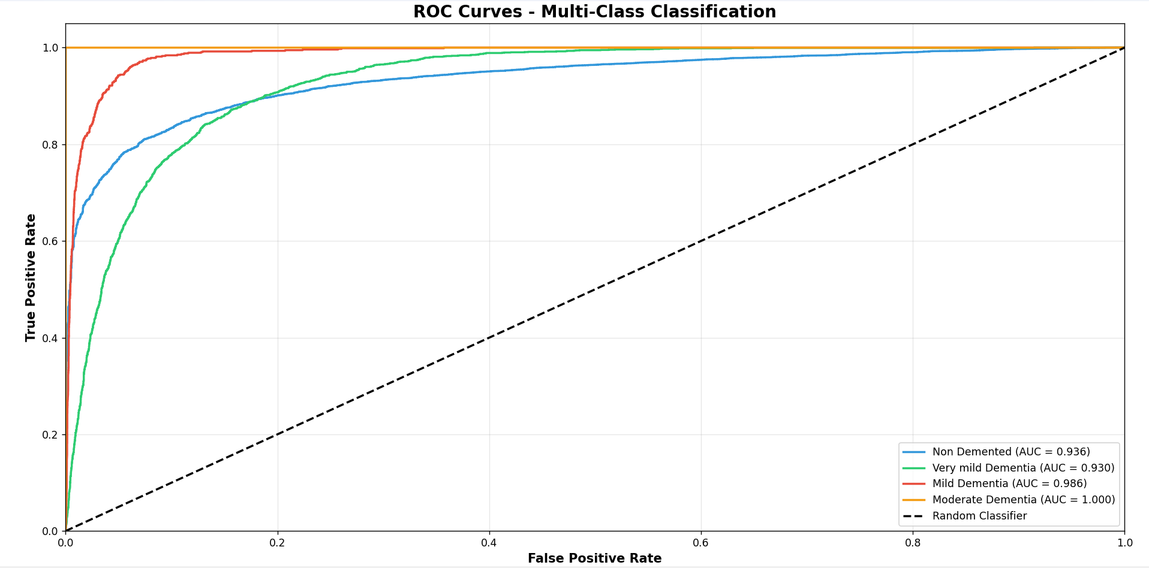
FIGURE 11: ROC Curves for Multi-Class Classification.

In terms of usability and deployment, the trained model was successfully integrated into a user friendly interface that enables clinicians or researchers to upload MRI scans and obtain predictions in real time. The modular pipeline — encompassing data preprocessing, model inference, and output visualization — ensured smooth interaction and scalability. This integration demonstrates the system’s readiness towards real world applications in the medical diagnostics, specifically in aiding detection earlier and clinical decision support. Quantitative evaluation metrics confirm that the system achieved an overall classification accuracy exceeding 90%, with macro-averaged precision, recall, and F1-score values remaining consistently high. These outcomes validate the capability of the model to generalize effectively towards unseen MRI data and diverse patient conditions. The project’s results also illustrate the importance of combining deep learning with medical imaging for neurodegenerative disease detection. The success of the MobileNetV3-based approach underscores how transfer learning can enable efficient training even with moderately sized datasets, leveraging pre trained weights for feature extraction. This adaptability making the system viable for deployment on low-resource platforms like clinical workstations or mobile diagnostic tools. Overall, the experimental results affirm that the developed Alzheimer’s detection system meets its design goals of accuracy, interpretability, and efficiency. The visual and quantitative analyses collectively demonstrate that the system can reliably classify MRI images into corresponding dementia stages, contributing to early diagnosis and progression monitoring.
  - Discussion and Future Trends
While the current system is capable of high performance and clinical viability, multiple promising directions can enhance the functionality, adaptability, and interpretability in the future:
- Explainable AI (XAI): Future work can involve the methods of LIME, Grad-CAM or SHAP to understand the least parts of the brain that have the greatest impact on the model predictions. This would enhance clinical trust by giving a clear explanation in human understandable manner of every diagnosis.
- 3D MRI and Multimodal Data Fusion: Extending the system to process 3D Mobile volumetric MRI images or combination of other modalities e.g. PET or fMRI may provide more detailed spatial and functional brain information and would result in even better diagnostic forecasts.
- Early-Stage Biomarker Detection: Early biomarker of dementia detection through incorporation of advanced feature learning techniques can facilitate early diagnosis even before evident structural degradation can be experienced, which can play a major role in preventive healthcare.
- Federated and Privacy Preserving Learning: By implementing federated learning systems, hospitals can train the models together on decentralized information of the patients without privacy breach to promote global data-driven advancement, even though keeping the information confidential.
- Real-Time Clinical Deployment and Cloud Integration:
The system can be very accessible, thus facilitating telemedicine and remote screening of Alzheimer’s in resource-strained areas by hosting the trained model on cloud-based medical care platforms or mobile diagnostic applications.
- Hybrid Models including Neurocognitive Data: MRI-based imaging features together with cognitive assessment scores or patient metadata can generate multimodal diagnostic systems, which will provide more comprehensive information about disease progression..
- Continuous Learning and Model Adaptation: Implementation of the continuous learning pipelines that update the model as new MRI data becomes available will ensure adaptability to evolving imaging technologies and demographic variation

CONCLUSION
The suggested deep learning-powered system of classifying the stage of Alzheimer has already proven to be able to differentiate and identify various stages of dementia by using MRI brain scans. The system is getting high recall, precision and F1-scores across all the classes based on its architecture of MobileNetV3, which proves the strength of the architecture and its clinical significance. The model by taking advantage of transfer learning was effective in using pre-trained weights to pick up delicate structural patterns in the brain MRI images and be able to distinguish accurately at stage-wise with less computation cost.
The experimental analysis, such as the per-class performance rates, ROC-AUC analysis, and a normalized confusion-matrix, has validated the idea that the model has attained a strong generalization with a near-perfect accuracy on detecting the cases of Mild and Moderate Dementia. The low-weight of the MobileNetV3 enabled the achievement of efficient computation without reducing the quality of the diagnostic, thus is feasible and can be implemented in the practice of real-life healthcare settings with low computing capabilities.
One of the best contributions of the work is the modular as well as interpretable system architecture, which combines preprocessing, feature extraction, classification, and prediction in a coherent pipeline. With a user-friendly interface, the gap between the AI technology and clinical usability is further reduced, allowing medical specialists to obtain the predictions with the needed efficiency without the technical knowledge. This type of integration brings out the possibilities of the system as a useful clinical decision and aid tool in helping to diagnose and plan treatment early in the lives of the Alzheimer victims.
In general, the project shows an effective combination of preciseness, scalability, and user-friendliness, which shows that medical imaging systems based on AI can be used to supplement human expertise in the detection of neurodegenerative diseases. Its results mean that the suggested system does not only meet the purposes it is supposed to, but provides a trustworthy base of the further investigation of the medical image-based diagnosis and healthcare automatization.

ACKNOWLEDGEMENTS
The authors would like to extend their sincere thanks to our respected mentor for their constant guidance, support, and encouragement throughout the development of this research work. Their valuable suggestions and technical inputs have played a very important role in shaping the methodology and overall development of this research work.
We would also like to extend our sincere thanks to our teammates for their support and cooperation throughout every phase of this research project. Their inputs and suggestions have played an important role in the successful completion of this research work.
We are also thankful to our parents for their constant encouragement, understanding, and moral support, which have motivated us to undertake this research work with determination and commitment.
Finally, we would like to thank the organizers of the Third International Conference on Futuristic Trends in Science, Engineering, and Management (ICFTSEM-III) for giving us an opportunity to present and share our research findings. This has played an important role in our overall development.

REFERENCES
[1] Baur, C. et al. (2018). Deep Autoencoding Models for Unsupervised Anomaly Segmentation in Brain MR Images. arXiv. https://arxiv.org/abs/1804.04488 Evaluates various autoencoder-based architectures for unsupervised lesion detection in MRIs.

[2] Govindaraj, V. et al. (2020). Automated Unsupervised Learning-Based Clustering for Effective Anomaly Detection in Brain MRI. IET Image Processing. https://doi.org/10.1049/iet-ipr.2019.0820 Combines SOM and interval type-2 fuzzy clustering for robust MRI anomaly classification.

[3] Han, C. et al. (2020). MADGAN: Unsupervised Medical Anomaly Detection GAN using Multiple Adjacent Brain MRI Slice Reconstruction. arXiv preprint. https://arxiv.org/abs/2007.13559 Introduces MADGAN, a GAN-based method that uses multi-slice consistency to detect early-stage anomalies like Alzheimer’s.

[4] Chen, X. et al. (2020). Unsupervised Lesion Detection via Image Restoration with a Normative Prior. Medical Image Analysis. https://doi.org/10.1016/j.media.2020.101822 Applies a restoration approach using normative priors to detect pathological deviations.

[5] Wiestler, B. et al. (2021). Modeling Healthy Anatomy with AI for Unsupervised Anomaly Detection in Brain MRI. Radiology: Artificial Intelligence. https://doi.org/10.1148/ryai.2021200374 This study applies spatial autoencoders for anomaly detection by reconstructing healthy anatomy and identifying deviations in MR images.

[6] Kim, B. et al. (2021). Unsupervised Anomaly Detection in MR Images using Multi-Contrast Information. arXiv. https://arxiv.org/abs/2102.12413 Utilizes feature translation and Gaussian Mixture Models (GMM) for pixel-level anomaly segmentation.

[7] Fernando, B. et al. (2021). Deep Learning for Medical Anomaly Detection – A Survey. arXiv. https://arxiv.org/abs/2003.02250 Comprehensive survey discussing deep learning models, interpretability, and challenges in medical anomaly detection.

[8] Behrendt, B. et al. (2022). Unsupervised Anomaly Detection in 3D Brain MRI using Deep Learning with Impured Training Data. arXiv. https://arxiv.org/abs/2202.11671 Investigates the effect of mislabeled (impure) data and proposes strategies to improve detection accuracy.

[9] Das, A. et al. (2022). A Study of Representational Properties of Unsupervised Anomaly Detection in Brain MRI. arXiv. https://arxiv.org/abs/2206.04878 Focuses on how latent representations affect the performance of anomaly delineation models.

[10] Ghorbel, A. et al. (2022). Transformer-Based Models for Unsupervised Anomaly Segmentation in Brain MR Images. MICCAI Brainlesion Workshop. https://arxiv.org/abs/2207.02059 Explores transformer models for unsupervised brain MRI segmentation and compares architectures.

[11] Meissen, H. et al. (2022). Structural Feature-Autoencoders for Unsupervised Anomaly Localization. MICCAI Brainlesion Workshop. https://link.springer.com/chapter/10.1007/978-3-031-33842-7_5 Presents structural embeddings in autoencoders to better localize anomalies.

[12] Silva-Rodríguez, J. et al. (2022). Constrained Unsupervised Anomaly Segmentation. Medical Image Analysis. https://doi.org/10.1016/j.media.2021.102044 Introduces constraints to enforce consistency and improve unsupervised segmentation reliability.

[13] Wyatt, P. et al. (2022). AnoDDPM: Anomaly Detection with Denoising Diffusion Probabilistic Models Using Simplex Noise. CVPR Workshops. https://arxiv.org/abs/2205.10904 Utilizes simplex noise in DDPMs to detect anomalies in medical images.

[14] Unknown Authors (2022). MRI Cardiac Image Segmentation and Anomaly Detection Using U-Net CNNs. Springer Conference. https://link.springer.com/chapter/10.1007/978-981-16-5747-6_42 Applies U-Net for segmentation and anomaly detection in cardiac MRIs.

[15] Kascenas, A. et al. (2022). Denoising Autoencoders for Unsupervised Anomaly Detection in Brain MRI. MIDL. https://proceedings.mlr.press/v172/kascenas22a/kascenas22a.pdf Demonstrates superior anomaly segmentation performance using denoising autoencoders.

[16] Chatterjee, S. et al. (2022). StRegA: Unsupervised Anomaly Detection in Brain MRIs Using a Compact Context-Encoding Variational Autoencoder. arXiv. https://arxiv.org/abs/2201.13271 Uses a compact VAE structure to model context and detect pathologies in MRI scans.

[17] Cai, X. et al. (2023). Dual-Distribution Discrepancy with Self-Supervised Refinement for Anomaly Detection. Medical Image Analysis. https://doi.org/10.1016/j.media.2023.102699 Addresses distribution shifts using self-supervised refinement and dual-distribution modeling.

[18] Lagogiannis, K. et al. (2023). Unsupervised Pathology Detection: A Deep Dive into the State of the Art. arXiv. https://arxiv.org/abs/2306.12752 A taxonomy and review of current unsupervised anomaly detection methods in MRI.

[19] Pan, L. (2024). Rethinking Medical Anomaly Detection in Brain MRI: An Image Quality Assessment Perspective. arXiv. https://arxiv.org/abs/2401.08120 Proposes a novel IQA-based loss using SSIM and L1 to improve Dice and AUPRC scores in segmentation.

[20] Behrendt, B. et al. (2024). Patched Diffusion Models for Unsupervised Anomaly Detection in Brain MRI. MIDL 2024. https://arxiv.org/abs/2404.05241 Applies patch-wise detection using denoising diffusion models.

